# 

# 

# 

# Technical Report Purdue REU 2023

Gabriel A. Baquero

Purdue University

Dr*. Daniel W. Leon-Salas*

08/2023

This report serves as a technical guide for future projects.

ORCID ID: 0009-0009-1759-4435

University of Houston

[Personal Email](mailto:gabor.baquero@gmail.com) / [Student Email](mailto:gabaquer@cougarnet.uh.edu)

## Abstract

Within the rapid advances to microelectronics, sensor technologies, and animal behavioral studies lies the potential to revolutionize the methods used to monitor and understand animal behaviors. This research demonstrates the design and implementation of a solar-powered, FPGA-based multisensory platform, housed within a size-constrained (25mm x 30mm) Printed Circuit Board (PCB), serving as an advanced tool for livestock monitoring and animal behavior analysis. The system integrates a Lattice ICE40 Ultra-Light Field Programmable Gate Array (FPGA), a suite of sensors including a temperature sensor, a light sensor, and an accelerometer which is all powered by a Gallium Arsenide solar cell. Furthermore, the FPGA coded hardware design has the possibility to enhance the capture and interpretation of real-time environmental and motion data as well as contributing to continued device iterations. Future research could aim to further miniaturize the device, integrate additional sensors such as those detecting noxious gasses like ammonia and methane, and incorporate a gyroscope for more accurate animal behavior data. Ultimately, this research represents a steppingstone in improving animal health monitoring and enriching animal behavior research methodologies.

Keywords: FPGA, VHDL, Sensor Integration, Solar Power, Animal Behavior Analysis, Livestock Monitoring, PCB Design.

Technical Report Purdue REU 2023 1

Abstract 2

- FPGA Usage 5

- Light Communication 5

Boards 8

- Main Board 8

- Programmer Board 8

On Monitoring Behavior 9

- Sensor Usage 9

Future Research 10

Technical Aspects 10

- JTAG Programming 10

- Board Datasheet and Files 13

- GUI Code and Programming 17

- 3D Models 21

Files 23

Acknowledgments 23

Appendix: Interview Summaries 24

Darrin M. Karcher 24

Dr. Greg S. Fraley 25

Dr. Luis Brito Interview 27

Dr. Erasmus 29

Jacquelyn P. Boerman 31

Dr. Jay Johnson (USDA) 34

Dr. Allan Schinckel 36

Dr. Schoonmaker 40

Introduction

In recent years, major advances in microelectronics and miniature sensors have led to the rise of smart connected devices and precision agriculture. There is huge potential to transform the way we monitor and comprehend animal behaviors by utilizing these technologies. Field Programmable Gate Arrays (FPGAs) offer capabilities that can revolutionize this process. FPGAs are integrated circuits that can be programmed and reconfigured after manufacturing – similar to how you can install different apps on a smartphone. This customizability means FPGAs can be optimized for specific applications like animal monitoring. Additionally, their parallel architecture allows for real-time processing of large streams of sensor data. To visualize why this is useful, imagine trying to monitor a herd of cattle by manually reviewing footage from security cameras versus using smart motion-detecting cameras that only send notifications when needed. The FPGA is like those smart cameras – able to analyze and respond to data in real-time. FPGAs also excel at high-throughput data crunching. Think of the difference between an old desktop and a modern laptop – FPGAs provide the computational horsepower needed to handle all the data from animal monitoring sensors. For these reasons, FPGAs enable more intelligent real-time collection and interpretation of sensor information compared to alternatives like microcontrollers.

## FPGA Usage

The Lattice ICE40 Ultra-Light FPGA was selected for this project due to its balance of low power consumption and high performance capabilities. Since the unit relies on solar energy and needs to operate outdoors, a low power chip is essential to minimize reliance on batteries. The ICE40UL FPGA consumes minimal energy yet can still handle complex monitoring tasks. Additionally, its compact physical footprint fits within the tight size constraints of the device's circuit board. Importantly, the reconfigurable nature of FPGAs allows modifying the chip's logic and functions as needed. Rather than being fixed at manufacturing like a microcontroller, the FPGA can be reprogrammed for design experiments and upgrades even after deployment. This flexibility accelerates prototyping and development compared to fixed-function alternatives.

## Light Communication

The device utilizes digital pulse interval modulation (DPIM) for wireless data transmission. DPIM is a modulation technique that encodes information in the varying time intervals between digital pulses of light. Specifically, the onboard LED as well as the IR electroluminescence (EL) of the GaAs Solar array can be pulsed on and off to generate light signals. The time durations between consecutive pulses can be modulated to encode the sensor data collected by the device. For example, a short time interval could represent a binary 0, while a longer interval encodes a 1. More complex encoding schemes are also possible, like mapping different pulse intervals to symbols in a communication protocol. Infrared light has the advantage of being invisible to animals wearing the device, so it does not disturb or distract them. The downside is that infrared light has a shorter range than visible light. Visible light enables longer transmission distances but may be noticeable by the animals.

A photodiode receiver can be used to detect the pulsed light signals from the LED flash. The time intervals between pulses can then be measured and decoded to reconstruct the transmitted data. The parallel processing capabilities of the FPGA enable real-time encoding of the sensor data into DPIM light signals as well as decoding of the received pulses. Key advantages of this DPIM light communication approach include:

* Wireless transmission avoids wires or heavy radio hardware.
* Light signals travel long distances and work outdoors.
* DPIM modulation is straightforward to implement on an FPGA.
* Infrared/visible light does not interfere with radio communications.
* Light pulses have very low power consumption.

In a more detailed light our FPGA uses DPIM in 2 different aspects on the transmitter side we have the following:

* The FPGA transmitter logic encodes each data byte into pulse intervals.
* It first splits each 8-bit data byte into two 4-bit nibbles - a lower nibble and upper nibble.
* It starts with the lower nibble. Each of the 16 possible 4-bit nibble values (0 to 15) is mapped to a unique pulse interval time. The mapping uses shorter intervals for lower nibble values.
* For example, nibble 0110 (decimal 6) could be assigned an interval of 6*T clk cycles. The higher the nibble value, the longer the pulse interval.
* An LED is pulsed on and off at the specified interval to transmit each nibble value.
* A fixed 'symbol extender' duration is added after each pulse, implemented as additional clock cycles. This extends the apparent pulse width to account for broadening during transmission.
* Without this extender, long pulses could broaden enough to interfere with the next pulse. Adding a constant extender prevents this inter-symbol interference.
* After encoding the lower nibble, the upper nibble is encoded using the same pulse interval mapping scheme.
* Once both nibbles are transmitted, the next data byte is split and encoded. This continues until all data bytes are converted to pulse intervals.
* Finally, a checksum byte is computed over the data bytes and transmitted using the same interval encoding method.

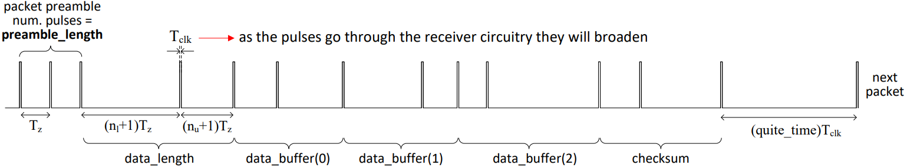

Finally, on the receiver side we have:

* The receiver FPGA logic measures the time intervals between incoming pulses.
* It uses thresholding to map the measured intervals back to the original nibble values that were encoded. Shorter intervals decode to smaller nibbles.
* The lower and upper nibbles are combined to reconstruct the transmitted data bytes.
* The checksum is verified by computing a new checksum over the received data and comparing it to the received checksum value. A mismatch indicates a transmission error.
* Matching checksums confirm that the data was received correctly. The data bytes can then be extracted for use by the monitoring system.

# Boards

## Main Board

The custom designed main circuit board measures just 25mm x 30mm x 5mm. This compact size allows the device to be easily attached to animal collars or ear tags for tracking and monitoring livestock. The small size also enables monitoring of smaller animals like rodents and birds in future versions. Despite its size, the main board packs in the Lattice ICE40 FPGA, a light sensor, accelerometer, and GaAs solar cell. For reference. Careful component selection and layout allows fitting everything into a footprint the size of a postal stamp. The ultimate goal for this device is for the following:

* The solar cell provides perpetual power to the system as long as there is sufficient ambient light.
* The light sensor lets the FPGA monitor the available light and optimize power consumption.
* The accelerometer tracks animal motion and behavior patterns like grazing, sleeping, and walking as well as early illness detection by monitoring limping.
* Finally, the temperature sensor should enable micro-environment monitoring.

Together, the comprehensive environmental and motion data provides deep insights into animal health and welfare.

## Programmer Board

To facilitate rapid testing and reprogramming of the FPGA, a custom programmer board was created. This board connects to a computer and provides convenient access to the ICE40 FPGA via industry-standard interfaces like JTAG, SPI, and I2C. For example, the JTAG interface lets you upload new logic designs to reconfigure the FPGA. The SPI and I2C buses allow connecting additional sensors or communication devices. The programmer board streamlines prototyping by avoiding the need to manually connect JTAG pins or serial protocols during development. It also serves as a reference design for how to interface with the FPGA in final applications. The board includes an FT232H USB converter chip to handle USB-to-serial translation for I2C communication with the FPGA, demonstrating how off-the-shelf ICs can supplement the custom FPGA logic.

# On Monitoring Behavior

## Sensor Usage

To effectively monitor animal behavior, the device needs to collect comprehensive data on the animals' motions and environment. Based on recommendations from animal science experts, the following sensors should be integrated:

* Accelerometer - Detects animal movements like walking, running, grazing, flopping down, etc. Abnormal motion patterns may indicate emerging illness.
* Gyroscope - More precisely tracks body motions and spatial orientations over time. Useful for monitoring detailed behaviors.
* Temperature Sensor - Identifies fevers associated with sickness. Recommended for internal body temperature.
* Light Sensor - Logs environmental light conditions and animal light exposure.
* Air Quality Sensors - Measure levels of ammonia, methane and possibly other gases.

Data from these sensors can be processed by the FPGA using behavior recognition algorithms. The parallel nature of FPGAs enables real-time analysis of the sensor data to identify behaviors as they occur. Predefined rules and machine learning techniques implemented in the FPGA can detect complex behaviors and health events. While wireless transmission or on-board storage can offload processing to other base stations or log the processed results respectively.

# Future Research

In the future, I believe aiming to further miniaturize the board to make a new line of devices that should allow monitoring of smaller animals like mice, hamsters, birds, reptiles, and most importantly insects. As of now integrating additional sensors like air quality detectors seems more plausible and could provide more perspective on environmental conditions. Adding a gyroscope or GPS would allow tracking animal location and movements with greater precision. And continued algorithm development and machine learning application holds promise for deeper behavioral insights. Ultimately this research serves as a foundation for electronics aimed at animal monitoring techniques and exploration of how IoT smart sensors can be applied within agriculture, science, and animal behavioral research.

# Technical Aspects

## JTAG Programming

The JTAG Programmer can be used to program any FPGA from Lattice, the programmer needs a certain amount of connections for it to work, these are: VCC (To check if the board has power); GND; SCLK (Clock Signal for SPI); TRST (Reset for programming errors); SS/CS; MISO; MOSI. Bringing the total amount of connections for programming to 7 pins.

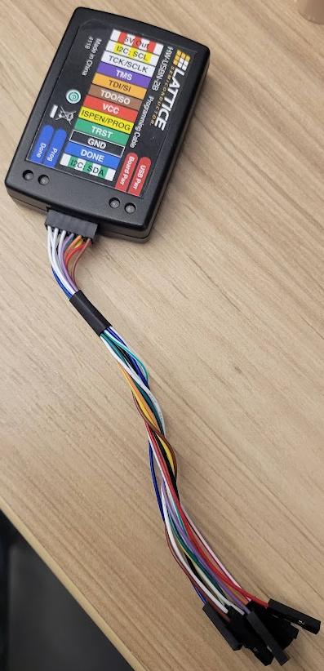

The connections from the JTAG to the board are done in the following manner:VCC to 3.3v, GND to GND, SCLK to SCK, TRST to RESET, SS/CS to SS, MISO to MOSI, MOSI to MISO.

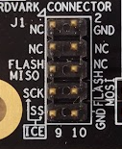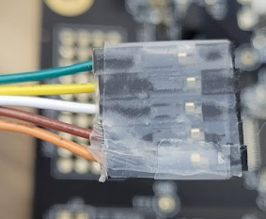

\Although these connections are necessary, the programmer can actually be “tricked” into believing the board has these connections, by connecting VCC to e xternal 3.3V power and pulling TRESET low by connecting it to GND, we can lower our connections to only 5, this is not recommended for untested bitmaps or new boards, as the programmer cannot reset the board in case of any errors.

In order to program the board using a bitmap you will have to install the [Diamond Programmer](https://www.latticesemi.com/programmer) from Lattice. Once you have downloaded the software, create a new project from a JTAG scan and connect the JTAG to your computer, then press “Detect Cable”.

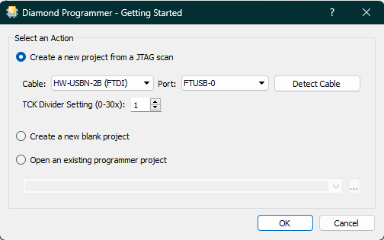

Depending on the device you are trying to program different things will be needed, however in order to program the main board load a project with the following characteristics.



Once you have done this click on, “Operation” and select the following settings and click “Ok”.

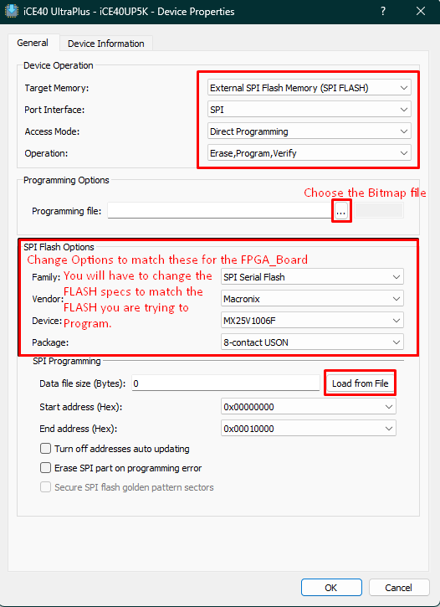

Now that you have selected all the right settings you can now program the board by clicking the button “Program”, wait for the software to finish and you can now save the programmer configuration for later use by clicking “Exit” and “Save”.

## Board Datasheet and Files

The main board has been designed to be as small as possible while keeping enough ports to be used as a dev breakout board, this design can be miniaturized even further by only keeping a POGO connection instead of the castellated design, however the main concern with it is to allow the connection of a Methane-Ammonia sensor module that can be attached and detached, and a better design to attach to the ear of an animal.

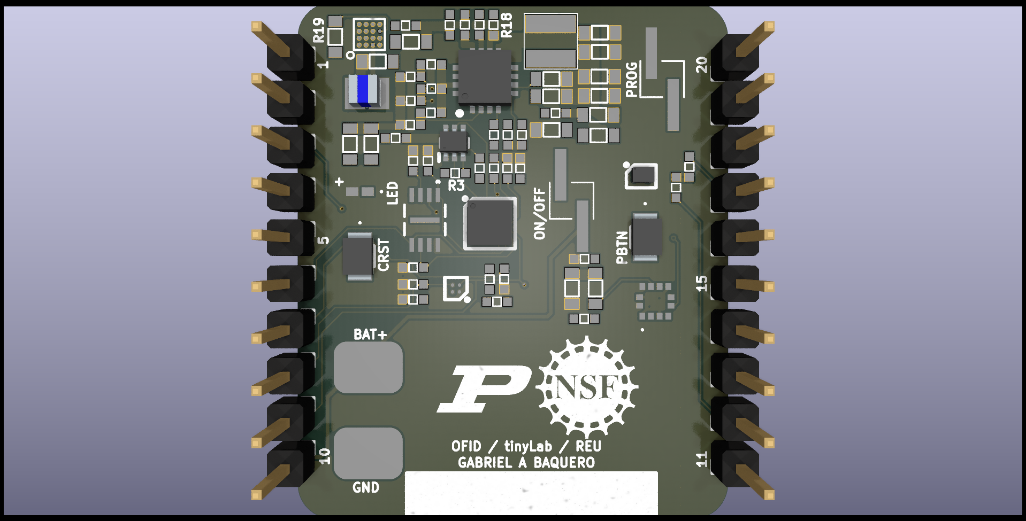

As for the pinout, each connections stand for the following:

1. PV+ – Positive polarity of GaAs Solar cell.
2. SYS – Test point for ADP5090 Energy harvester.
3. SCK – Flash and FPGA Clock signal.
4. IRLED – Infrared LED light connector.
5. BRCDE – LED Connector.
6. FL_SI – Flash MOSI + FPGA MISO.
7. CRST – Pin for RESET circuit.
8. I2C_SCK – I2C Serial Clock Input.
9. I2C_SDA – I2C Serial Data Input.
10. JMP1-PAD2 - Battery test point.
11. IC1-DRAIN2 – LED Array Positive connector.
12. 3V0 – 3 volt input.
13. CDONE – FPGA CDONE circuit test point.
14. IC3-IN- – Op Amp negative input testpoint.
15. FL_SO – Flash MISO + FPGA MOSI.
16. CS – Flash chip select + FPGA slave select.
17. GND – Ground connection.
18. A3 – Op Amp output connection test point.
19. IC3-IN+ – Op Amp positive input test point.
20. F3 – FPGA IO Pin.

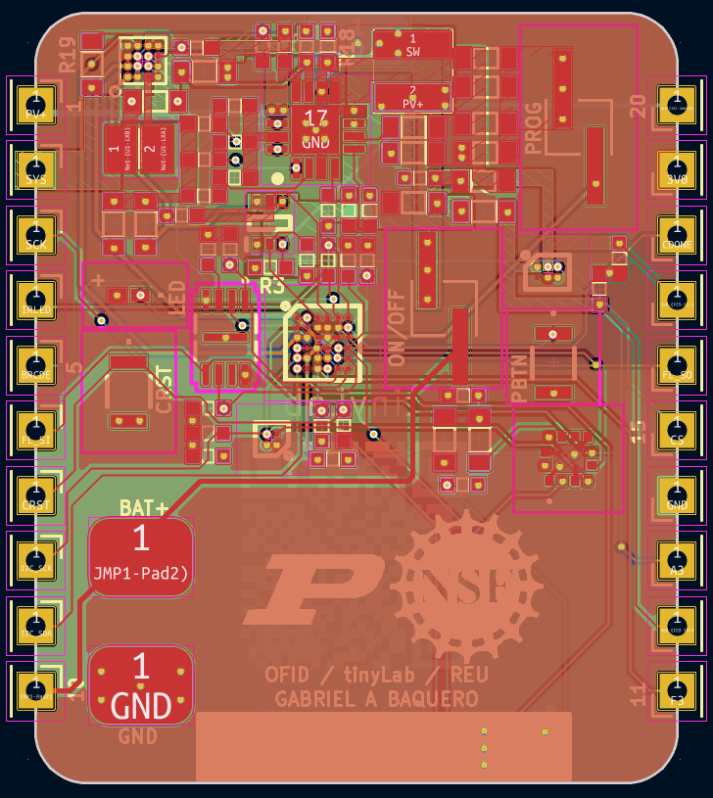

The programmer board has been designed to be reusable for any board that has the same pinout connections, in the event the board wanted to be used is not 100% compatible, we can just take the necessary connections by using the male pinout included on the board, effectively turning this into an external FTDI/JTAG-POGO programmer, finally, the board has a battery charger that can aid the main board, as well as a switch that can program the flash using SPI or control the I2C mode of the FPGA.

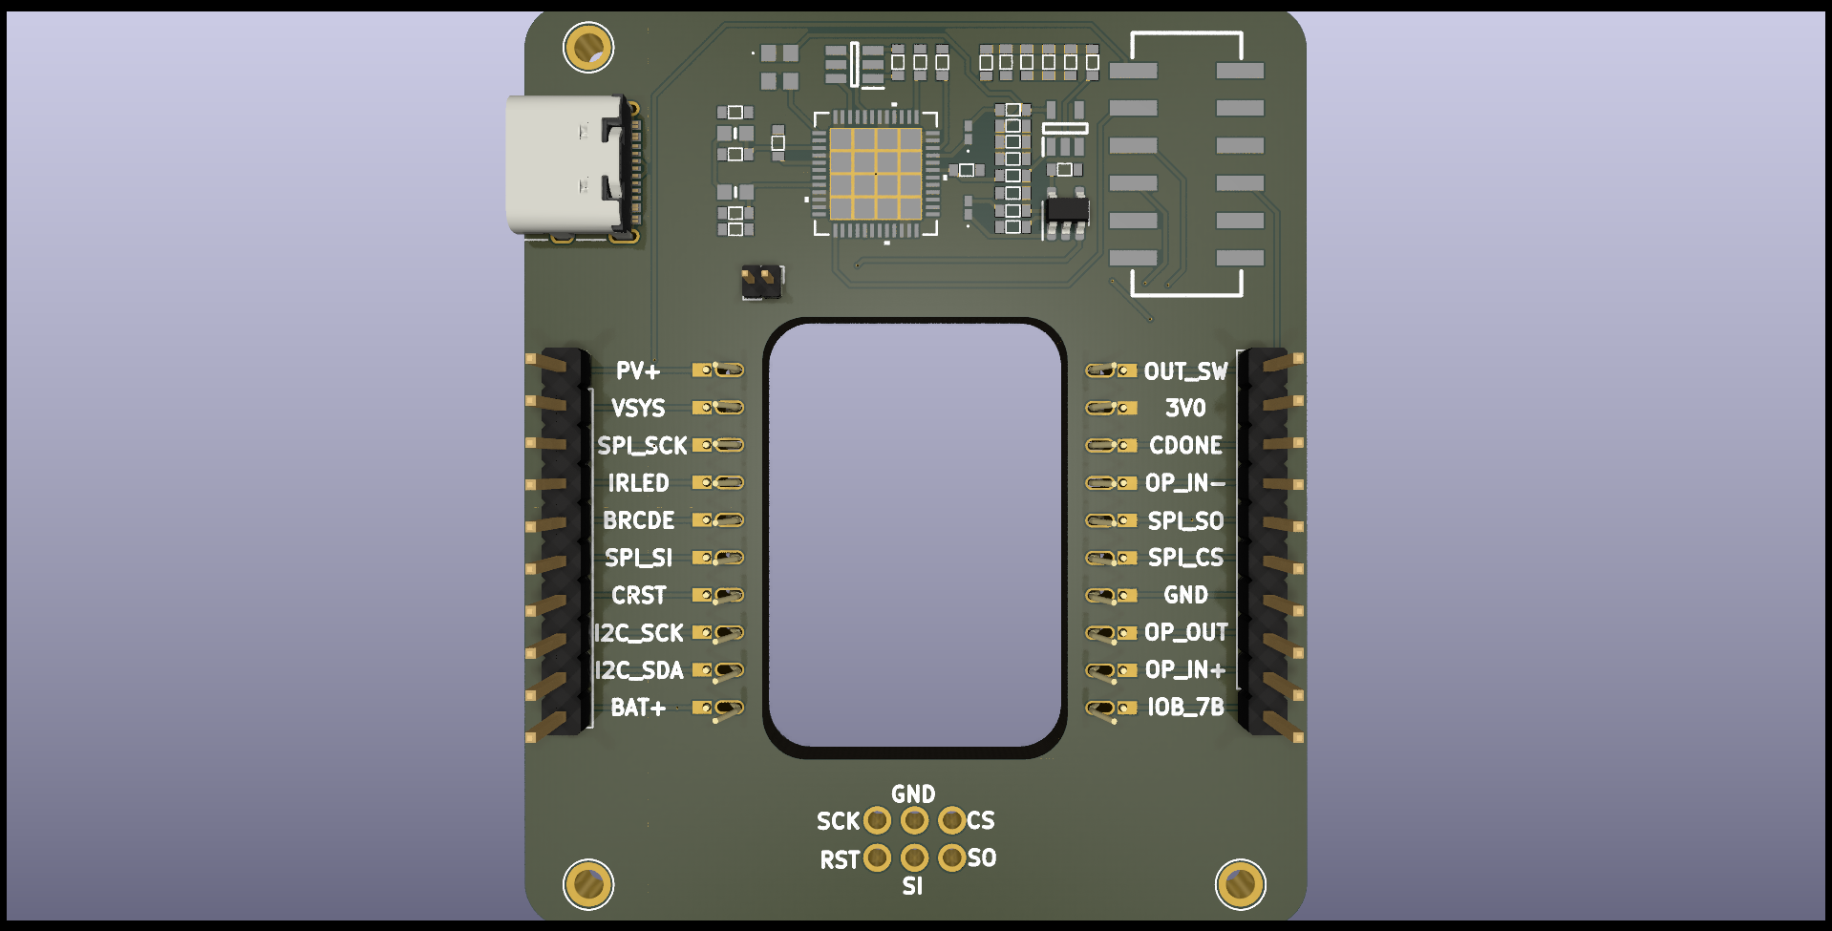

The programmer board has a connection for all pins from the main board as well as adding a POGO connector for quick JTAG Programming of any sort, there’s also the addition of a FTDI chip that serves as a quick programmer option in case POGO fails or it is not available, the only connections worth noting are the Jumper connector (J5) which serves as a battery charger for the main board, as well as the switch (S1) which can control the state of FTDI control between SPI and I2C. Note: There is a chance the switch will not work as the datasheet of it was cryptic to read to day the least, in this case please refer to the following schematics and make the necessary connection to connect a simple jumper in its place.

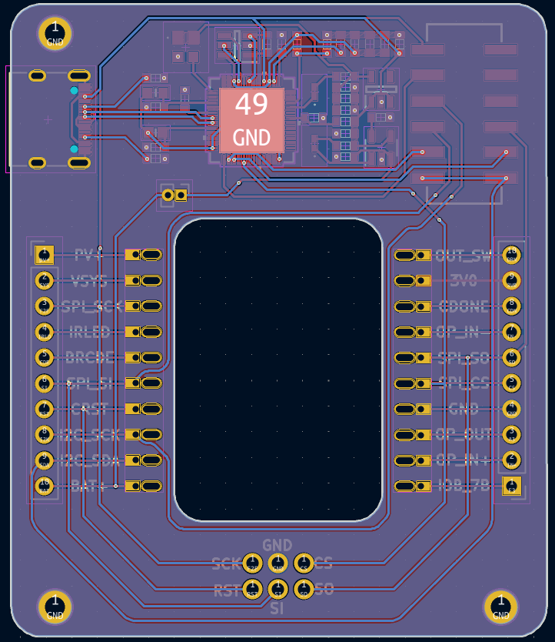

## GUI Code and Programming

LVGL ([Light and Versatile Graphics Library](https://docs.lvgl.io/master/intro/index.html)) is a free and open-source graphics library providing everything you need to create an embedded GUI with easy-to-use graphical elements, visual effects and a low memory footprint. In this project, we use LVGL for the ESP32 Board whose main purpose as for now are that of DPIM decoding/receive - encoding/transmit, the board is a bit complicated to program however this part of the report will guide you through the set of steps to program the board from the Arduino IDE. In order to program the board we first have to add it to the Arduino IDE, to do this we go to “File > Preferences” and select the following:

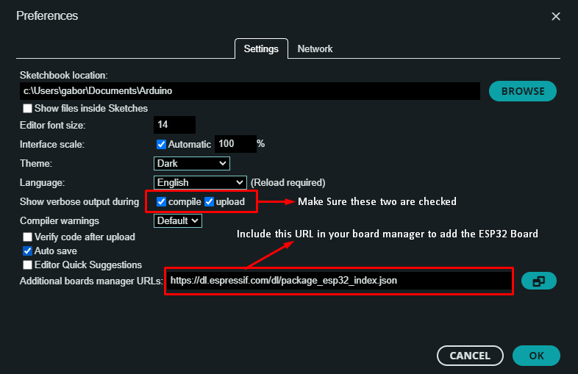

(“URL: https://dl.espressif.com/dl/package_esp32_index.json ”)

Once you have done this we can add the board to the IDE by going to ”Tools > Board > esp32 > ESP32 Dev Module” just as shown here.

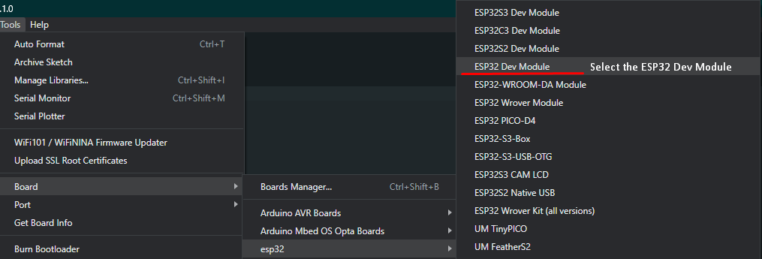

Finally, we will have to set the preferences of the ESP32 board to the settings shown here, once this step is done we can upload any code by selecting the upload button, and waiting for the IDE to erase the board’s flash (Note: If you receive an error such as “The ESP32 is not on programming mode” take it outside the box, and press the button called “Prog” which is on the right side of the “Reset” button, keep pressing this button until the ArduinoIDE has finished programming the device, then disconnect and reconnect the board)

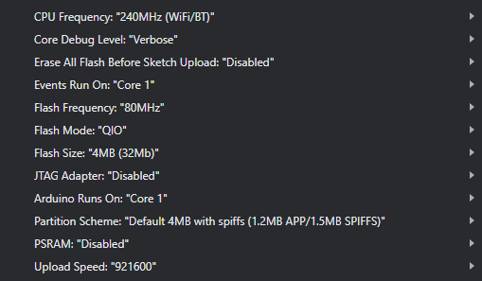

Now that we have setup how to program the board, we can edit the code that will go into it, for this we use the program ([SquarelineIO](https://squareline.io/)) a software provided by LVGL that offers a relatively easy to use interface to create and edit LVGL GUI interfaces, in order to load the GUI currently used by the ESP32 we have to open Squareline studio, select “Import project” and click on the file located in “OFIDReaderGUI > Squareline > OFIDReadeGUI.spj” once you open the file you will be met with a screen detailing the project’s settings, so make sure they are the same as the ones shown here.

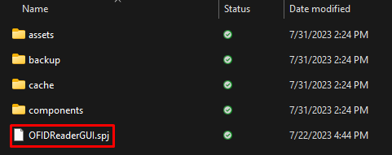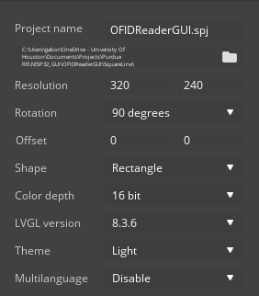

In order to load the current GUI into the ESP32 board you first have to copy all libraries located in “OFIDReaderGUI > Libraries” into your arduino “Lib” folder, usually found in “Documents > Arduino > Libs” if you cannot find it, just zip EACH individual folder one by one, and include the zip using the Arduino IDE, once you have done this open the ui file located in “OFIDReaderGUI > ui > ui.ino” and upload it to the ESP32 using the aforementioned settings.

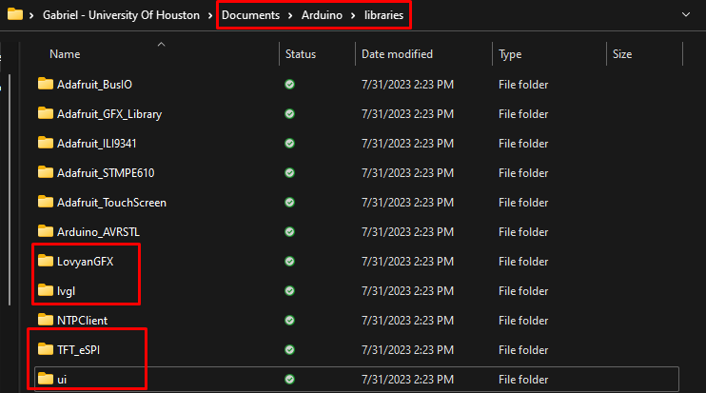

Whenever you create a new ui design and exported the necessary files to upload into the board, you can copy all of the folders generated by Squareline into the arduino “libs” while also copying your custom config for “lv_conf.h” as well as the TFT_eSPI “user_setup.h” file into the new folders, an easier way to do this is to just copy the folder "ui" into the arduino libs, however go with the first method if you encounter any compiler issues.

Note: There is a possibility that Squareline compiles a “screen” that you are not using, in that case the arduino compiler should throw out an exception handler error, if this happens, go into the ui folder ui/src/screens/ and delete whichever screen is giving you errors or that shouldn't be there.

Board troubleshooting: If you ever encounter any error regarding board programming or anything of the sort, refer to the following steps to revert the board to the “Factory settings”, first download the file “2.8inch_ESP32-2432S028R” then go into “8-Burn Operation > flash_download_tool > flash_download_tool.exe” once you have opened the app select the chip and workmode, then start the app by selecting the bin file located in “8-Burn Operation > Burn files > LVGL-DEMO2.8R.bin”, and finally press “START” and wait for the operation to say “DONE” once the program is done, reset the board by disconnecting and reconnecting the USB cable.

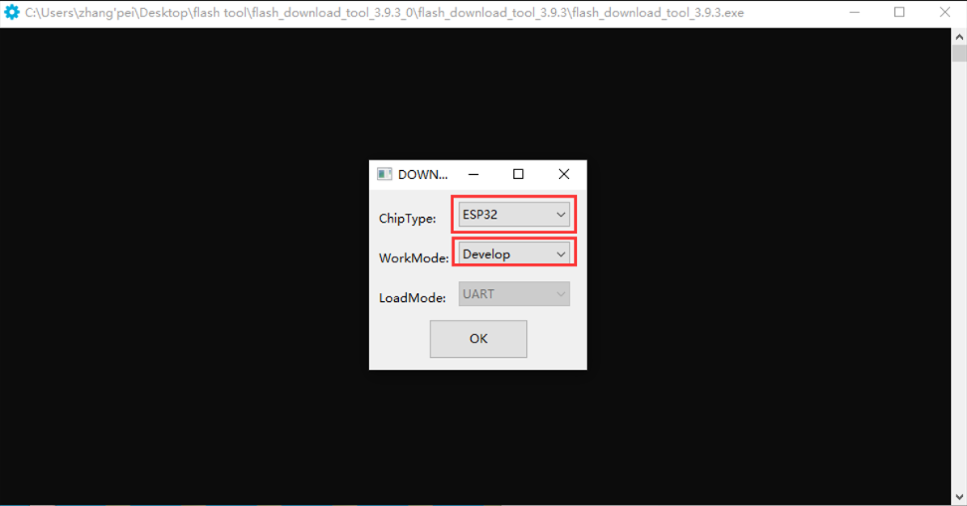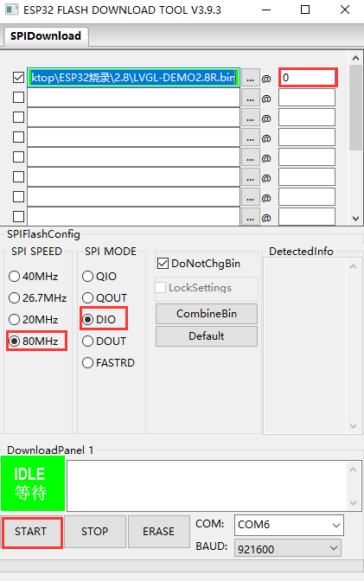

## 3D Models

This section of the report will supply the 3D models in various file formats in order to make it easier for future editing, the first model covers the ESP32 Board in its entirety, this cover also serves as a module for a bigger case which will house the laser + camera module.

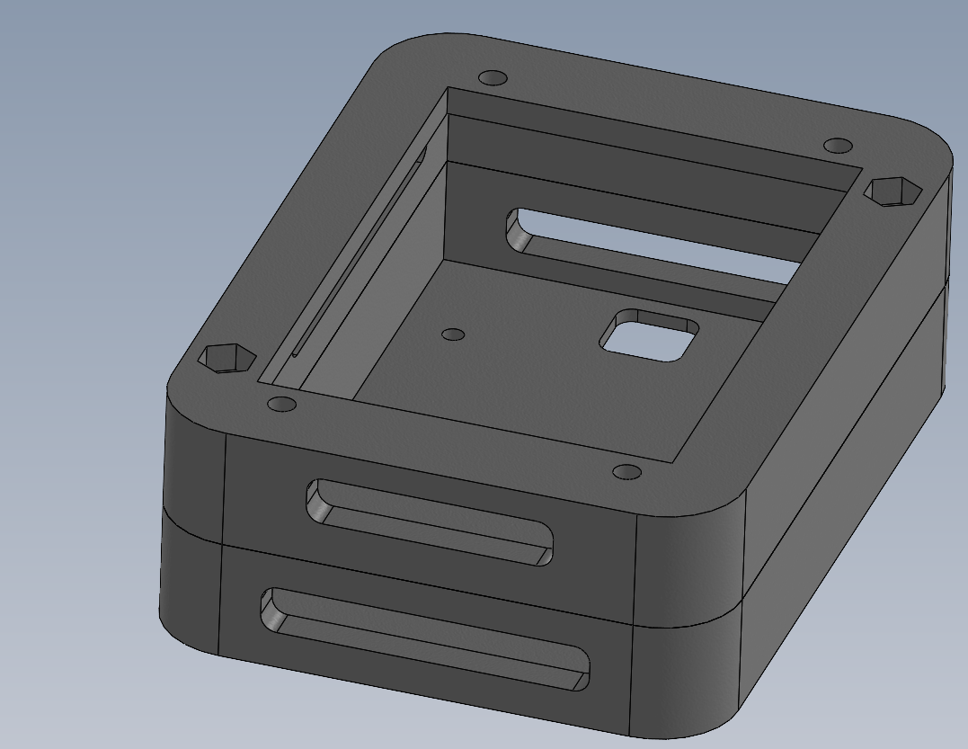

The first model can be printed from a single .step file, in a normal printer bed that is 200x200mm, the ESP32 Board is held by a few screws, and right below it there is a small pocket for the double PCB responsible for signal processing.

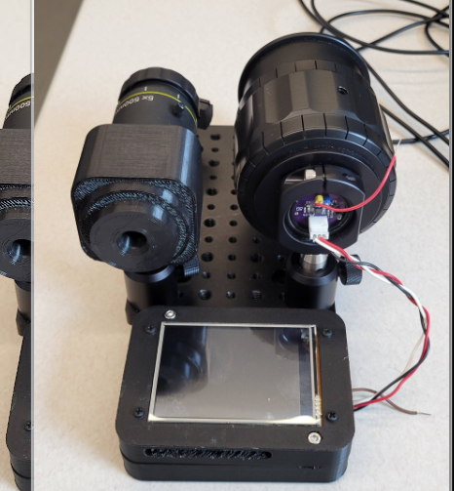

As for the second model, I tried going for something “exotic” and that looks like a rocket engine, however, with the requirements that it needs to house the full (Laser + Camera) device, while also looking “cool” it ended up being quite big (The entirety of the case costs about 1.5 kg of PLA/Printing plastic), making it hard to print on a regular sized printer , however, if you go ahead with using the model, it would be possible to divide the case into 4 parts for later reassembly, Though, if a bigger printer bed (400x400x600mm) is provided it would be possible to print the entirety of the model in one go, this would provide more structural support to the whole part and be easier to work with later down the line.

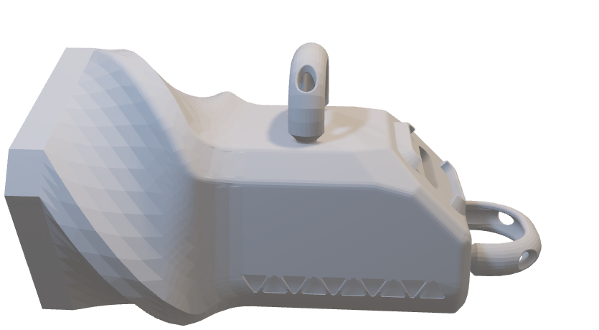

# Files

The following link will lead you to a drive folder containing every file used in this project ([Link](https://drive.google.com/drive/folders/11Phf_cXjrGyJVAydHleW5n4dRKl3DifD?usp=sharing))

# Acknowledgments

I would like to express my sincere gratitude to my advisor, Dr. Daniel Leon-Salas, for his invaluable guidance, support, and expertise in the successful completion of this research project. I am also grateful to my co-advisor, Dr. Lisa Bosman, for her assistance and insights during the summer months. Their contributions have significantly enriched my research experience and professional growth.

# Appendix: Interview Summaries

## Darrin M. Karcher

Chickens would have no access to any litter; they would all have this belt above them, a wire mesh floor, and a belt to remove them from the bottom.

* The farm is stacked over the stack.

Do you think using solar cells in this condition is possible?

* Every system would have lighting, and the intensity of the light would drop as you go from a top tier to a bottom level. Chickens can go to areas where it is darker and the other regions where it is lighter. Free-range organic: they can also go outside and have natural light.
* How can our product influence: temperature, humidity, dust, obnoxious gases (ammonia, no hydrogen sulfide, and nitrogen.) The big one that everyone pays attention to is ammonia. If we can sense ammonia, that would be very helpful.
  + Right now, there are ammonia probes or handheld devices. Wet litter with excreta from the birds causes ammonia. If the product identified patches or areas that have more ammonia than others, it would be easier to treat that spot instead of the whole area.
  + Even if it’s not alarms, seeing ammonia levels increase, we can be responsive promptly to address those concerns. Significantly during the winter season, because there is minimal ventilation, the number of fans is reduced. So maybe if there is a high level of ammonia, it can be automated to turn on a fan to ventilate the area, or now he can trigger a fan also to ventilate the area.

If the system is AI ventilated. Long-term, what we are constructing is pivotal to create a more comprehensive knowledge of poultry. We are still at the level of monitoring houses at a house level, he’s trying to monitor micro-climates inside that house.

* + Probably the biggest thing, would be a temperature display. As you’re walking through the house, you are not going to investigate the display unless it is important and big.
  + There is a publication at UC Riverside, where they were using a small accelerometer device to monitor the behavior of birds.
  + If we can start to have an accelerometer or gyroscope. If birds are 6 feet up in the earth, some things are preventing us from knowing the welfare of the Earth. Where they go eat, where they walk in the area.
  + At this point, we have been talking about laying hens; you could apply it to broilers or turkeys; the systems we discussed could be single-plane, where the meat birds only move in x-y coordinates. So, monitoring would only be in that plane.
  + Turkeys 13-20 weeks, hens are upwards from 90 weeks.
  + Housing sizes for meat birds, 20k population, they don’t move as fast when they have breast meat, and it would be easier to read as you walk into the house.
  + Chickens are harder to monitor because they have several stacks.

## Dr. Greg S. Fraley

* Environmental conditions to measure: Light intensity in terms of mW/cm^2, not LUX.
* Color spectrum would be very helpful, as temperature, humidity, and ammonium levels (preferably even though it’s complicated).

Movement, some accelerometer, to see how the chicken moves and where in the barn.

* Normally wing tags are about 3x5 mm in size.
* Need to make a model that works, that works in the lab. Then give it to him, put it in a chicken for two weeks, and see if it still exists. Seems like a simple step until you can prove that the sensor can survive in life with a chicken.
* We can put it in the wing to be stable. When we attach it, it’s like in the earlobe, so it is not hard or tough, so if the sensor flaps around, it will irritate the bird and it will destroy it.
* Sensor tags are in the back; they make harnesses to hold the sensor.
* Good for research but not so much for farmers.
* Encasing: It needs to be tough, hard; if it’s on the wings, they will peck at it. Would suggest in the back, same color as the bird, avoid red or blue. Waterproof. Lightweight.
* Display: In terms of workstation, normal limits for variables, but if the bird goes above those normal levels, then it would be essential to know.
* Anything over 25 ppm – Ammonia.
* CO2 – would also be good to check.
* Accelerometer: if the bird moves have not moved in 2 hours, then we need to move.

Any other sensors:

* Bird’s body temperature.
* Light sensors: where is that bird spending its time during the day, like where in the barn is it spending its day.
* Emphasize before anything; we need to prove it will survive on a chicken because even if they survive a sheep, it does not mean it will survive a chicken.
* Pigs will go out of their way to eat the sensors.
* Placement is very important, like where in the body and how much the bird recognizes is there. The only way to know for sure would be to do a quality test.

He can also check with chicken and duck folks but through email.

## Dr. Luis Brito Interview

First, it’s a neat project and very useful for scientists. Challenges:

* Working with different spaces.
* If we attach to chicken, it cannot be heavy since they grow very fast, if we are attaching it to their wings or backs, if it’s heavy it can compromise their welfare.
* We have a lot of chickens together, are the interactions between the sensors. Multiple animals in a small pen, are there any challenges to collect the data, considering their interactions. With the RFID reader, we don’t know which animal is there.
* Pigs love biting everything they see, but if attached to back of pig, so they are fat and rounded (no neck), so attaching it to the pig is hard because it is similar to the human skin, so attaching it to the pig hurts their skin. When they are close together, they will bite each other.
* Helpful to collect body temperature in pigs for climate change because they are very sensitive to heat, so it would be helpful to know how it affects them.
* One option in pigs is to put them in the ears, some of them have floppy ears or different shapes. So, we could replace one tag that is already used with the one we have, which is slightly bigger than the one Gabriel showed.
* Ammonia is important for pigs.
* Methane is important for cows it comes out of their mouths.
* For cattle we can attach to their back of the necks, they are easier to attach to them and beef kettle they stay outside so they get more sunlight.
* Breed of sheep: Katahdin, they do not grow any hair.

How sensitive is the sensor to dirt?

* Chicken there is poop, dirt in the floor, pigs like to play with water and lay down their backs.
* Cows are easier because even if they lay down the sensors will not touch as much floor.
* Lens of cameras start to get very dirty, or if there is corrosion because of water.
* Humidity in farms.

Are we using any chemicals that could kill the animal?

* Like we complete the sensor, but they need to get through an approval to show how it works and how it can affect the animals.
* Something we need to be aware of, because if we are working with a species that eats it, we don’t want it to harm them.
* Or we can also stick to the skin of the cow.

In his line of work as a geneticist, when he downloads the data, he needs to keep track of which animal is which. He needs to know the data of each sensor, and does it link to each animal. Basically, to merge the information between sensor and animal ID.

* Accelerometer: most farms already have them to know the number of steps per day, how fast they are walking, whether they are laying down, whether it is eating, that would make it easier to sell it.
* Already technologies available for it, like for chicken, that have problems walking, their foot is hurt or something, so they will move different, it will be additional information that we will be able to collect.

To know animal interaction, like which animals are close or touch together.

* Agonistic interactions, like pigs fight a lot to establish hierarchy; who is more dominant and submissive.

Additional Contacts:

1. Schinckel, Allan P. aschinck@purdue.edu Pigs and sensors.
2. Boerman, Jacquelyn P jboerma@purdue.edu Cattle and sensors.
3. Schoonmaker, Jon jschoonm@purdue.edu Beef cattle.
4. Johnson, Jay jay.johnson2@usda.gov Say that he suggested we reach out to him.
5. Pempek, Jessica - ARS Jessica.Pempek@usda.gov USDA for cattle.

We can find them online the RFID for pigs to attach them:

https://extension.psu.edu/rfid-tags-for-use-in-swine-in-pa

<https://www.hogslat.com/electronic-id-ear-tags?gad=1&gclid=CjwKCAjw-vmkBhBMEiwAlrMeF3U741Cn0H1-mvIJW0tJb4Y_g7ZBJYC7YZccnRHMe4xC6n4RuQ4BfxoCfTAQAvD_BwE>

<https://www.ncbi.nlm.nih.gov/pmc/articles/PMC8947510/>

## Dr. Erasmus

Animals are a lot smaller, so finding sensors that size is challenging.

Ten of thousands of animals in one place. In poultry house indoors, sensors that need light might be challenging, some have windows, and some are fully closed. Moisture, ammonia, dust.

The behavior of the individual, they look the same to us. How to check it without causing problems without other birds, since it would be the only different one, and would make it a target. Even having readers through sensors would be helpful, she uses cameras and marks the animals with a type of paint, so they can identify it.

* Low levels of light, usually means out of the sun. Feather pecking and cannibalism, can be very bad, draw blood and die from that. One way to control that is to reduce lighting so they don’t peck at each other.
* They can see under UV light (poultry), depending on the type of poultry.

Meat birds.

* Not very active.
* Do not live as long.
* Egg chickens will keep them for 8-9 weeks, or a year. Keep them laying eggs until they’re spent, and they are cheap, so they might gas them to death.
* Meat 6 weeks.
* Meat processing facility, so if there is a sensor in those birds, it could go into the meat.

Sensors

* Related to humidity, to get temperature-humidity-related readings, because they get as affected by humidity and heat as us.
* We often measure light intensity, because as the bird moves, they pass through pockets of light.
* Baby birds something stack together, and they don’t know why, and they can die because of that.
* Within the environment, there are microenvironments, so they want to know what the condition for that microenvironment is at all times.
* Even something about CO2, or if the oxygen is dropping, and the birds are about to die soon.

One of the struggles is movement, having a marker on an animal to train the computer to find the checking: object detection, things like that.

Example: Go find me that chicken at 10 A.M on the video, and then a student would not have to do that. Link what they are doing to how healthy they are.

She works with most things that have feathers, so if we make one, we can put in any poultry.

They are working on putting accelerometers in turkeys, so they have problems with walking.

Egg laying problems with stacking or pecking.

## Jacquelyn P. Boerman

-        Dairy cattle, rarely grazing, most are in confinement housing. Most of those animals will be in barns.

-        Lighting how prevalent is it: Limited light at night, they do better if there’ slight on and off, maybe 8 hours of limited light availability.

-        During day, natural and fluorescent lighting.

Sensors

-        All the cows they do research on, they do activities every day for them, even location within a pen.

-        A sensor for behavior.

-        Multiple things at one time.

-        They usually do not have a collar.

-        Placement: Moving forward, an accurate measurement,: ammonia, methane, that will be a stagnant animal within a pen, it would be her methane and her ammonia, it will be the environment.

-        Already temperature and humidity sensors.

-        Environmental conditions that these cows are experiencing, the amount of steps, those things are already.

Some metrics are more population based.

* Humidity and temperature might not make sense.
* Ammonia and methane are unique to the animal, but we would be measuring the environment itself.
* Gyroscope: unique to the animal.

If we are designing a device for each animal:

* Temperature and humidity – no sense.
* Ammonia and methane – interesting, but
* Those would be for environment.

Two separate lenses= individual things we want to know about each animal, like her location, how much she’s walking, etc.

Things that we need each animal in a pen.

Are we designing these measurements for comparing different farms, or just as a group?

What would be useful for her? She wants to know from a video and know who that animal is, by assigning an ID to it. How many minutes she’s lying each day, how many magnitudes she’s at water, that would be useful.

Unless it is touching the animal individually, it will be more about managing the population. It would not work a lot for her.

She’s saying for dairy cows, they are loose and in groups. They have more freedom to move, temperature and humidity would be more for a weather station instead of individual readings.

-        Twist your ankle and limp, they can get limp and make a head bop unique to them when they’re limping, that would be very helpful.

-        Knowing to make it through video, by using IR cameras, however what does she expect out of this device. Like does she want to look at a video feed and get receipt.

o   No video footage, extract information from video footage and it IDS cows, her leanness is a 3, like algorithm says her head is bopping at a certain rate. Like rn she uses pattern recognition, and only works with animals that use certain color patterns. It is hard to distinguish them on video. A way to extract information from footage while algorithm is running in the background.

-        She wants something that could supplement what she could get through cameras, like how many times they walk through this camera this time, or two times. Body weight, body shape, microexpressions on the face by video camera because it shows up if they are sick.

-        If the system could tell you who’s animal is close to who for exposure to sickness.

-        Cameras cannot be everywhere on the farm

-        So systems that can tell you depending on the spatial movement.

-        Time spent at the water, time spent laying down, eating. Stuff like that.

Would u be interested in the possibility for this device to smart storage things? You could scan and get individual cow its own storage, breeding, genetic materials, input everything into there.

-        She would also like that because she has RFID tags on cows already but if it could be included inthere, because there’s more history to that animal.

-        Some of this does exist though.

-        Going back to the systems that she uses, detects different facial expressions and how they move.

-        Would it be possible it this device is more like machin learning, is it a company, or research? Just research. There are companies that are already doing this like:

-        CATTLE EYE, look at individual cows, determines if they are lame or not.

It’s cool we are working with it, to see how animals are housed to see how it will be integrated into the animal.

## Dr. Jay Johnson (USDA)

Input:

* Have we looked into the market to see what the differences are?
* Biggest issue devices:
  + How to attach it and get reliable data.
  + An accelerometer on the ear would not be accurate because they move their ears independently.
  + They used it some 9 years ago, and they did it intravaginally, which worked. But not for commercial
  + The neck would need to have a pretty strong adhesive.
  + IP67 Boxes on everything so things could work.
* COOL things and stop them from getting corroded.

The ability to make the device and is rare, and they can make the different devices. the biggest hurdle is making them robust enough to be on the animal and the environment.

1. If things only do one or two things is because they have to be more robust.
2. Check with the materials engineer.

-  Looks into temperature sensing:

IButton, rudimentary devices, can be calibrated.

Company: OnSet Hobo - temperature, accelerometers, livestock feet.

Iceland company: STAR ODI, devices implanted surgically. Really accurate.

* Limit to how long to leave intravaginally,
* Surgically on the flank.
* Ideally: Regulatory response, heat-stress, animals are sensitive to it. Temperature is very important.
* Automated of respiration rate, heart rate, and early signs of heat stress on set.
* Precision livestock farming technologies.
* Alert systems.
* Maybe not in every animal.
* Accelerometry is cool but depends on the placement of the animal too.

Accelerometry: Signs to look at

* If it tells everything the animal is doing.
* They have lots of algorithms to track animals to see what they are doing.
* The biggest point of interest: changes in behaviors, being able to track change over time periods.
  + Over a seven-day period, it is moving inactive 30% moving 70%, and let's say that those movements switch, then it is sick or something.
  + The facility of short staff, but to have a machine that can do all that, it will serve to be more precise.

To have a base station, what would be the best things to see on screen:

* Specific concerts, control what you see.
  + If it’s for research, then it depends on what you wanna see, like they want to see everything. So they have a computer system at: ventilation, gas, and water intake; pig did not know how to use a waterer, so those things are very helpful.
  + Purdue Farm is nothing compared to how it is. 12 times the scale of a normal farm. 6000 breeding animals, then baby pigs.
  + Fair Roacks, Indiana. Tourist production scale, they show u dairy, poultry.

## Dr. Allan Schinckel

* Neck collars for cows would be better.
* Pigs the ear tags, need to have an ear piercing, and it looks like a spear, which is bigger, and when it goes through the ear, it uses a button to attach it to the ear. Some ear tag is used on cattle and pigs. The baby pigs have an RFID tag, which has the pigs ID, so the tag gets close enough to the reader and stores the data of how much that pig weighs.
* People selecting pigs for genetic selection for improvements.
  + It will record how much feed the pig is eating; those feeders are pretty expensive, bc the pigs smack against the feeder.
  + With the LEE and OSBORN F-recording device, they can choose the pigs.
  + They have some temperature sensors, mostly in females, and in sous vaginas, which are used for sheep; they use an I-Button for data, every 6 minutes, to record how the temperature goes up and down.
  + I-Button is a little device that is about the size of 3 dimes, goes through a calibration procedure, which has 47-43 C, records what data they collect and calibrates the data, and downloads the data off of that.
    - It only has so much memory space.
    - Program to record every few minutes, but cannot record as long.
    - Dr. Swalee, internal heat sensors in real-time.
    - Sensors have to be pulled out right now.
    - They have a little string, and when they are done with the trial they just pull it out.
    - Internal temp is more accurate than the skin temp because it is in interface with the environment.
    - Very little has been done to measure the movement of the animals than pigs.
    - Chinese are looking at facial recognition, to see if it has different faces and neck.
    - It takes a lot of space to hold all that information.

Dr. Ni is an expert in ammonia detectors and some gas detectors, where one 12-room swine environmental building. Seraf building collects samples of gas and has tubes to measure the gas that is leaving the room, and it connects to

* hydrogen sulfide.
* When animals get up in the morning, and they all get excited, the ammonia levels and hydrogen sulfide levels go up.
* Methane is dangerous; when they feed pigs a certain thing, they can form gas bubbles which are dangerous for pigs because it is highly flammable.
  + Methane produces if agitating the manure.
  + If pigs are dying because of manure pits, which have to be cleaned sometimes, because when agitated.
  + It is a cycle, so animals and people can die very quickly.
  + Bad safety things: Ammonia levels of 10-20 ppm, affects the growth of the animal and it affects the lining of the lungs.
  + We could have it in a few animals, and the animals are closer to the pit level, which is not gonna rise right up to the ceiling.
  + Get it closer to the floor.
  + Ammonia levels for poultry will probably be higher at the bottom. Depends on the waste management.
    - Broilers, turkeys and ducks. Their environments are good at the beginning. At the time they mark their weight, they get worse and worse, because the ammonia levels go up.
    - Once the manure produced by baby ducks starts to decompose, it can produce methane and ammonia.

Type of sensors.

* hydrogen sulfide, but that one you can smell more.
* methane will also tell if there is a gas leak.
* carbon dioxide gets high, but then radiation has to be low.
  + utiric acid. odor is hard to measure and evaluate.

Placement of device:

* Put in a catheter in the jugular, and super glue on top of the pigs' shoulders for no more than a week. Pigs' hair is like paintbrushes, and their skin can be used for 3rd-degree burns.
* Pigs don’t like harnesses.
* They don’t like things on their feet.
* Accelerometers, speedometers, they like to know how much cows are moving and where they eat pasture.
* Two acres per cow, some are 100 brush land per cow, since they are so spread out.
* Look at the tags, the Lee tag has a spear and it has a button side, which is loose 1-2% if they get into a fight. sometimes the pig gets a cauliflower ear, then that ear tag has to come out. so that shape will stay.

Dust in swine places is corrosive, so salt and charges can corrode the metal. Copper will turn blue really quickly. Once the paint is off the metal, it will start rusting very quickly.

1-2 microns in size, electronically controlled pads to lessen that problem. Because if air gets in there, there is condensation, it will corrode the wire within 6 months.

Dust is hard to filter.

6-8 chips to check where it is colder in some places than others, but does not have to be in the animal.

But the animal’s movement should be improved.

Peer line animals that are selected- very intense performance testing. So they check genomic detections, growth data, weight data, and record how much data on how much the animal moves around. they want to select the best animals. Breeding stock companies check that the most.

If this is developed, this will need to file a patent and copyright.

Cooling pads work very well, but they have to be very sturdy, and used on boars, 37 C outside, and 450 animals.

40 ppm is obnoxious-unsafe, a farm collects ammonia in a corner, and 30 ppm is also awful to humans.

There is a plug to remove the plug on the manure, and someone passed out due to that gas, so it may be used as a safety tool because it becomes hazardous for others.

## Dr. Schoonmaker

Does the sensor have to be in contact with the animal’s skin: No, it’s more for the outside environment. There are devices that can already do that, an energy harvester (from a solar cell).

Placement:

* Beef animal: ear tags, could be there, and incorporating them there would be easy although sometimes they are lost.
* Pig: they don’t usually have ear tags, they usually use notches, so he doesn’t know what he would use on a pig.
* Chickens: might also have that problem, especially because they lose some feathers.
  + Maybe on their leg that could work, since they use a wedding band.
  + Also, maybe with a flexible PCB.
* Cattle: could go on an ear tag easily.

He was wondering about the price.

Sensors

* Animal’s temperature.
* Some of these tags with gyrometers, which have an algorithm to see the head/jaw movements when they feed.
  + Tags names: we have to ask.
* Gyrometer to recognize if the animal is sick.
* Somehow use the motion to check an intake.
* (This is what researchers would like)
* Animal’s individual methane. Very close to the mouth. So he might just get a general methane sensor, not just for the animal.
* Ammonia: useful information.

Price

* If reusable: a few dollars, under 5-10 dollars. given it could be used for 5 years or something.
* Purdue has invested more money than that.
* As a researcher, he would be willing to pay more if it is accurate. Around 20 dollars.
* Every year 200 calves, 200 cows, 400 animals, and if each animal has a device (that would already be around 8k)
* If sensors, maybe change the sensor that identifies the animal and be able to change it for each animal.

Medium

Seems like a lot of information, so maybe a computer to do a thorough check. But also, an app, to do a quick check. (Basically both).